Today’s Objectives:

- Working with Titanic Survival Prediction
  - Data Visualization
  - Handling Missing Values
  - Dealing with Categorical Variables
  - Building the model with training data
Use Machine Learning to create a model that predicts which passengers survived the Titanic shipwreck.
    - Logistic Regression
    - Decision Tree Classifier
  - Predicting the model on testing data
==================================================================
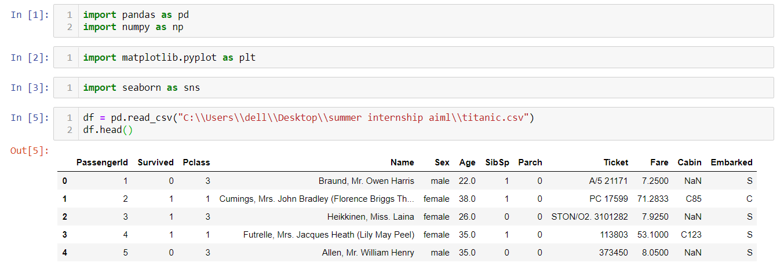

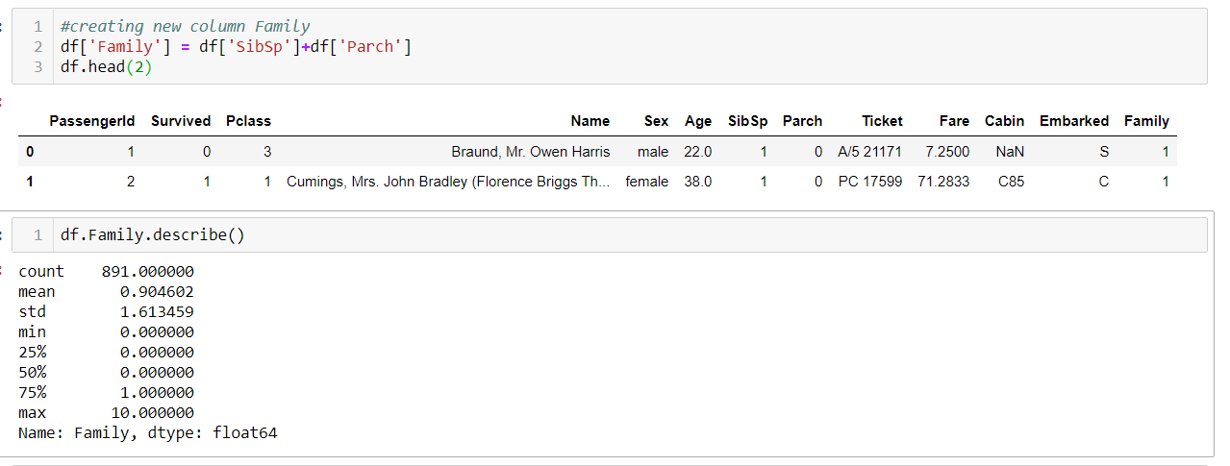
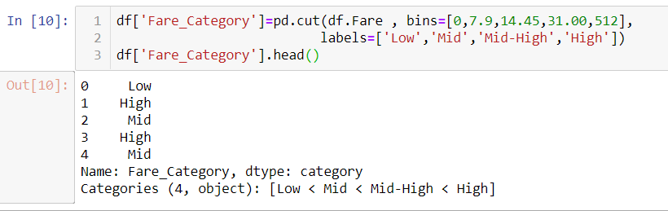

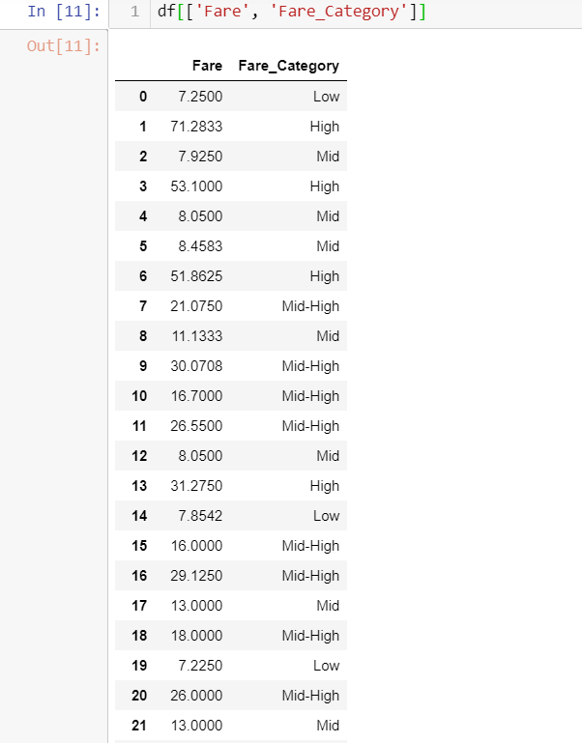
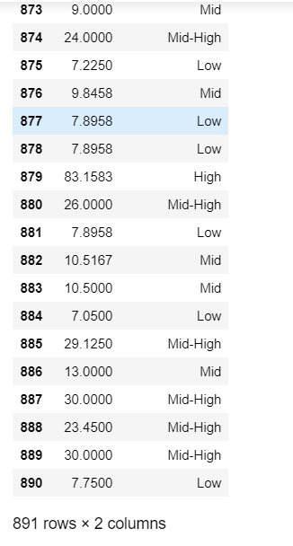

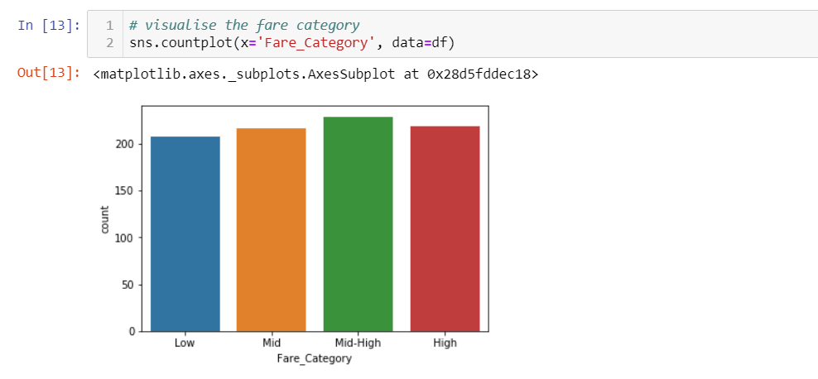
OBSERVATION:
the barplot clearly says that we have more amount of people who are in the middle-high fare category

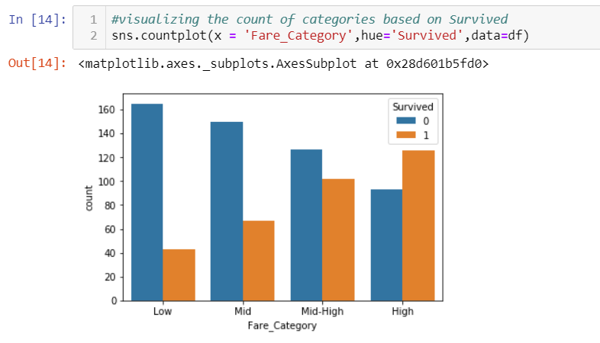
OBSERVATION:
Takes the bar plot we know that blue stands for people who r not survived and orange is for depicting survived count...we can observe that in the low fare_category we have more chances of losing the person..as the price of the fare increases the survived count also increased

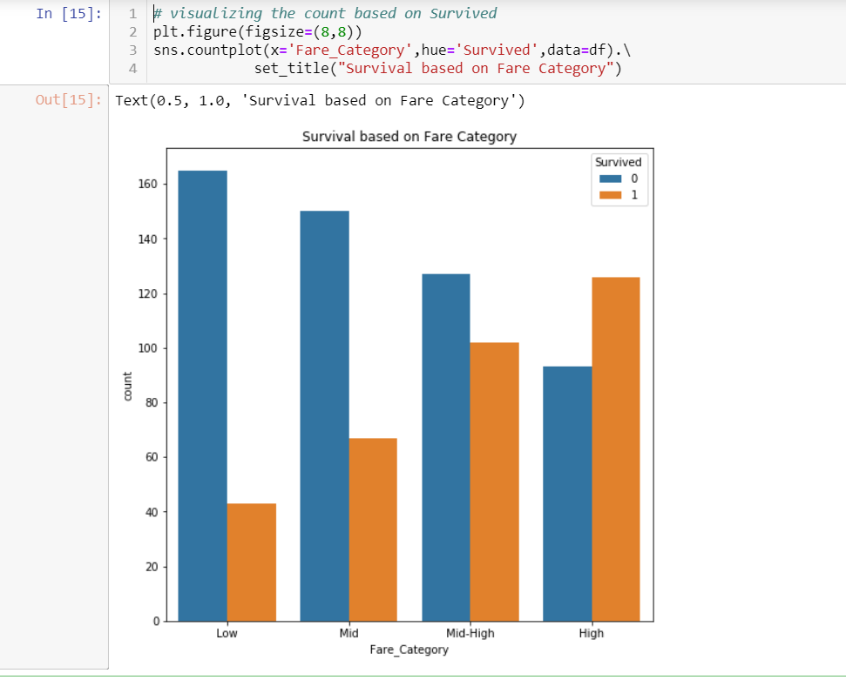
OBSERVATION:
The bar plot clearly says that as the face price is more the chances of survival is more and chance to be prone to disease is low
Hence Fare_Category is directly proportional to survival
Indirectly proportional to deceased

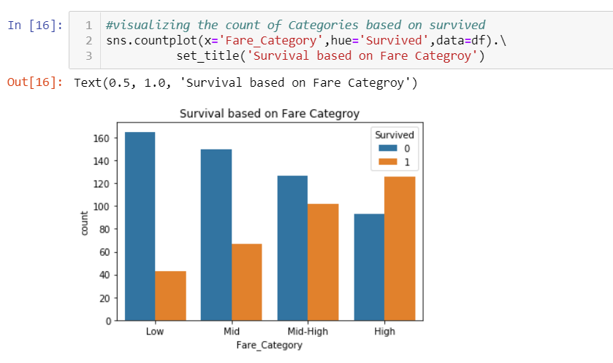
OBSERVATION:
The above barplot and this are the same ..the only difference is the size

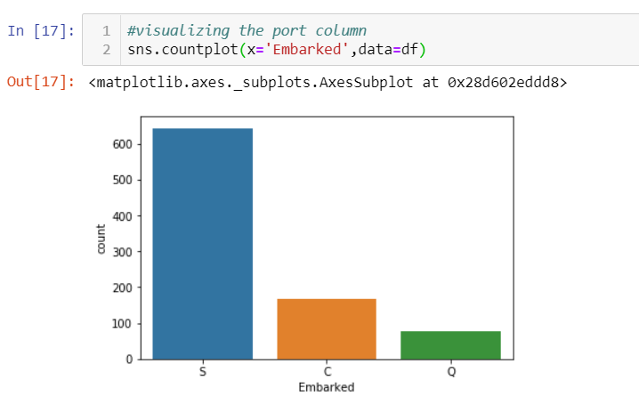
OBSERVATION:
This barplot depicts the count of passengers who came i.e boarded from different ports namely S,Cand Q

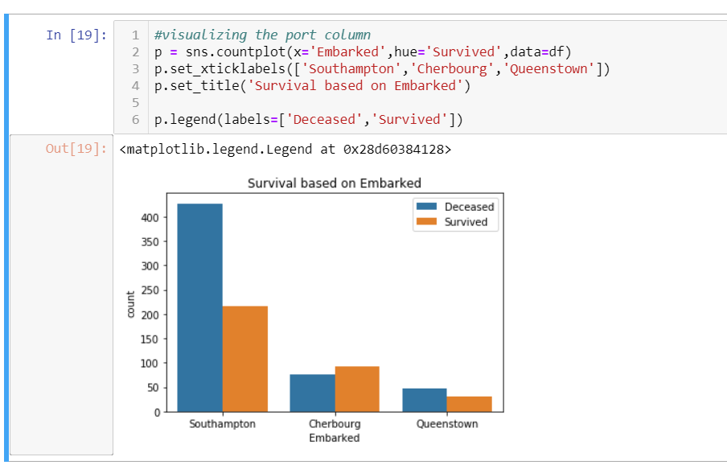
OBSERVATION:
This barplot shows us the count of passengers who boarded from differents ports and the amount of people who are deceased and survived.it shows that we have many people from Southampton where more than 400 are deceased

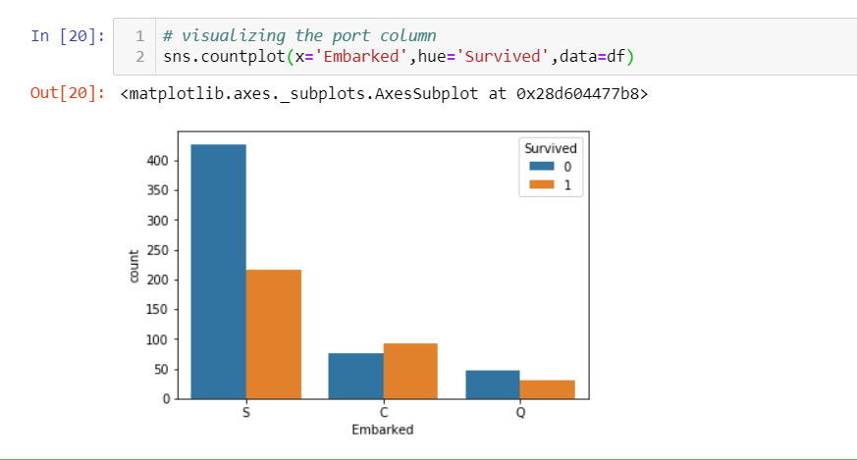

Imputing the Cabin column

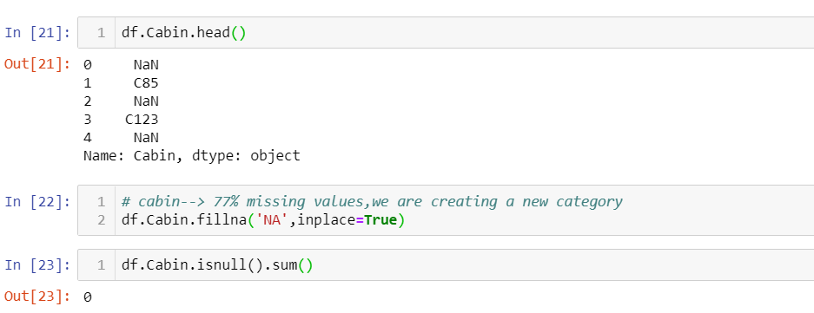
Imputing the Age column

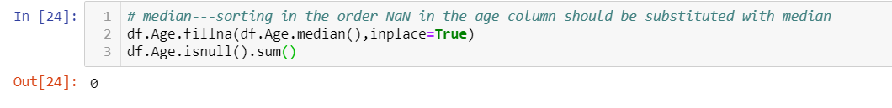

Imputing the Embarked Column

